**Design Proposal**

|  |  |  |  |
| --- | --- | --- | --- |
| **Project #** | **BB1** | **Date** | **November 24, 2016** |

|  |  |
| --- | --- |
| **Project Title** | **Aircraft System Filters - Means to Extend Useful Life** |
| **Client** | **Bombardier Aerospace Ltd.** |
| **Client Contact** | **Amanda (McCoubrey) Floyd**  **amanda.floyd@aero.bombardier.com** |
| **Teaching Assistant** | **Vincent Iacobellis** |
| **Supervisor** | **Prof. Kamran Behdinan** |
| **Prepared By** | **Christopher Prost**  **Mahtab Amiri**  **Odo Bingyue Wang**  **Shuwen Cao**  **Zhiqing Xu** |

**Table Of Contents**

**1.1 Problem Statement****3**

**1.2 Scope****3**

**1.3 Identification of Stakeholders****4**

**1.4 Functions****4**

1.4.1 Primary Functions 4

1.4.2 Secondary Functions 5

**1.5 Objectives****5**

**1.6 Constraints****6**

**1.7 Service Environment****6**

1.7.1 Physical Environment: 6

1.7.2 Human Environment: 6

1.7.3 Virtual Environment 7

1.7.4 Sample filters collection sources 7

1.7.5 Input Testing Parameters 7

1.7.6 Filter Dimensions: 8

**2.0 Alternative Designs** **9**

**2.1 Design 1 - Modular Filter Pressure Drop Tester** **9**

**2.2 Design 2 - Integrated Filter Monitor****10**

**2.3 Design 3 - DOP Test - Breakthrough Curve****13**

**3.0 Proposed Design****1****5**

**3.1 Operational Principles****17**

**3.2 Preliminary Implementation Requirements****18**

**3.3 Preliminary Economics****18**

**3.4 Preliminary life cycle & environmental impact** **19**

**3.5 Preliminary human factors & Operational Method****20**

**3.6 Preliminary Test Plans****20**

**3.7 Outstanding Decisions****21**

**4.0 Updated Project Management Plan****21**

**5.0 Conclusion****22**

**6.0 References****23**

**Appendices****26**

**Executive Summary**

Bombardier Aerospace has asked for a design that can resolve the problem of replacing air filters prematurely, as filters are frequently removed well before their operating lifetime limits. Filters are rated by the supplier for a set number of flight hours, however these do not accommodate for numerous variables in operation. The region’s air quality, aircraft frequency of use, and other variables will all have an effect on the operational lifespan of the filters. Currently, air filters are replaced with little indication of remaining life, and once a filter is removed it cannot be reinstalled without significant economic and time costs. Bombardier is searching for an easy way to evaluate the remaining life of the air filters after they get replaced in order to evaluate an average maximum lifespan for filters in their region of origin.

The primary stakeholders in the design project are Bombardier, the University of Toronto, and various other technical groups with the expertise to use and maintain the design. Thus, the public has limited exposure to the design, and the design’s scope can be further refined with regards to functions and constraints.

The function of the design should be to accurately evaluate the remaining life of the filters by providing accurate input and output flow criteria, as well as developing a model for evaluating the expected life span of a filter. Moreover, the design should be adaptable for a series of varying filters and be portable enough to allow transportation by a single operator without specialized equipment or tools. Furthermore, the design should be easily operated and maintained, while ideally minimizing the cost to Bombardier. The design must not overestimate the lifespan or alter the functionality of any of the filters being tested, whether by deconstructing the filters, modifying their flow, or otherwise. The design must also accommodate for ergonomic and safe design principles.

Given the aforementioned design criteria, a number of design alternatives were developed using problem decomposition. Each design was compared on the advantages and disadvantages it held, with respect to the project objectives. Then, using a pairwise comparison and weighted decision matrix method, the designs were compared against each other. The modular filter pressure drop monitor design was determined to be the best amongst the alternatives, and is the proposed design for this project.

The proposed design functions on blowing air through a series of modular ducts adaptable for each filter being tested. The design functions on pressure losses and flow rate changes in correspondence with Bernoulli’s principle, and will demonstrate the degree of pressure drops within the filter based on its age. The design uses primarily OEM-supplied parts for high compatibility, cost effectiveness and ease of maintenance with respect to the human factors of the design. Outstanding decisions are contingent on the results of the preliminary test plan, which will analyze the effectiveness of the adapter system for consistent flow. The current material cost of the project is approximately $3,500 CAD for the proposed design.

# 1.1 Problem Statement

Bombardier (as the Client) is seeking for a method to easily evaluate the remaining life of cabin and component air filters in the aircraft (Q400) after they are replaced. Currently, replaced filters are not considered to be useable based on the operator's initial glance, as standardized testing methods have not been developed. Purchasing new filters is expensive and further financial costs are incurred by the downtime associated with maintenance. The lifespan of the filters are dependent on the air quality and composition in their regions of origin, as higher particulate levels would reduce the filter’s operating lifespan. Therefore, samples from different environments will be used to test remaining life of the air filters.

Bombardier owns a 10 ft long testing bench at their headquarter that can simulate the aircraft system airflow to test whether the air filters are meeting the failure criteria indicative of their end-of-life, and thus the ideal replacement rate. However, due to the size of the bench, air filters have to be collected by maintenance operators and shipped to the test center to get tested, and the design has non-standardized parts making replication difficult. This whole process is time-consuming and can be shortened by providing a method to test air filters at the operator’s discretion. There are three air filters with different shapes and specifications in air crafts: safety valve filters, display panel filter and cabin filters. Filter samples will be collected from various regions including China/Japan, Africa, North America and Europe. The design should be able to fit for all these three types of filters. The design must be portable to carry and able to be used the at operator’s own maintenance schedule.

# 1.2 Scope

The task for this project is to design a portable prototype that can be used by the operator to easily evaluate the remaining life of the air filters in order to fully use the filters before replacing them. The whole project is divided into three stages:

Stage 1 (Sep.2016 - Dec.2016): Prototype design and construction

Stage 2 (Jan.2017 - Feb.2017): Prototype testing and improvement

Stage 2 (Feb.2017 - March.2017): Simulation operation on replaced filter sample

In Stage 1, Team works on prototype design solutions and construction. The prototype is tested in Stage 2 for design improvement. After the design passed the testing stage, the prototype will be used on all three types of replaced air filters to evaluate their remaining lifetime.

The Design Team will start to build the prototype for the cabin filter, because it has the highest requirement for the flow rate. Combined with a flow rate control valve, the prototype can be adjusted for other types of filters. The requirement for the project is to design a prototype that can be used for cabin filters. Designing a prototype that can fit for all three types of filters is an extension of the project.

# 

# 1.3 Identification of Stakeholders

This section identifies parties that will influence the design of the project*.* The degree of interest expressed by a stakeholder thus affects the extent of their impact on the design. As the design is not intended for use by the general public, the design shall be targeted towards use and distribution by maintenance and management teams.

*Table 1: Table of stakeholders & their respective interests in the design*

|  |  |  |
| --- | --- | --- |
| Stakeholder | Interest | Impact on design |
| Capstone Project Team | Complete 4th year project and build connection with the client | The design must be feasible to produce within the duration of the Capstone course |
| Capstone Project Supervisor | Meet clients’ expectation and ensure students learned through the project | Design team needs to apply the knowledge of engineering design |
| Bombardier Aerospace | Increased filter lifespans will lead to increased return on equity for Bombardier | The design must be cost efficient and provide accurate data |
| Commercial Airlines | Reduced maintenance costs from reduced filter replacement frequency | The lifespan calculations must be sufficiently accurate |
| Design Operators | Ease of operation will lead to increased user satisfaction | The design should meet ergonomic use objectives |

# 1.4 Functions

The function of this design is to accurately evaluate the remaining life the three different types of particulate air filters installed in a Bombardier Q400-series commercial aircraft. The functional basis of the design is to transmit information to the user (maintenance operator), as per the following primary and secondary function.

## 1.4.1 Primary Functions

The design should:

* Display the input and output air flow criteria through a particulate air filter
  + The design must indicate the air pressure, air temperature, and volumetric **or** mass flow rate before and after the stationary air filter
* Calculate and display the expected life span for a filter type in its region of origin
  + The design must determine the projected flight-hour lifespan for an air filter type in its region of use

## 1.4.2 Secondary Functions

In order to accomplish the primary functions, the design should:

* Modify testing parameters by user operation
  + The design should be adjustable for the various testing parameters required by each filter
* Develop an extrapolative mathematical model for the expected lifespan of a filter
  + The design should use the OEM rated lifespans for comparison
  + The design will use a clean, unused filter for calibration

In order to complete its intended purpose, the design must be able to determine the input and output air flow rate through a filter, at a preset input temperature and pressure. Once the flow rates are determined, the design must be able to extrapolate the expected lifespan from various filter flow rates and service hours. This will allow for the design to use a mathematical model to determine the expected lifespan of each filter in its region of origin.

# 1.5 Objectives

In order to improve the user experience, the design should seek to achieve a series of objectives. Each is quantified by an objective goal, and a corresponding metric (where applicable) for the determining the design’s success in meeting its goals.

The design should be:

* Easily adjustable for various filters
  + The design’s filter adapter assembly should be modular
    - Goal: The operators (normally aircraft maintenance technicians) should spend no more than 5 minutes replacing a filter. (Airplane turn time, time required to unload an airplane and prepare for the next departure, is about 60 minutes[9]. Changing the filter of the device should not take too long so that technicians can finish their work within the turn time..)
    - Metric: Measure the time taken to install a filter
* Portable
  + The design should be easily disassembled to fit in a Q400 cargo hold
    - Goal: The design should be easily disassembled to fit in Q400 cargo holds for transportation from site to site
    - Metric: Measure dimensions of the design to fit cargo loading requirements
  + The design should be easily disassembled into components transportable by a single person
    - Goal: Disassembled components should weigh less than 50lbs to comply with workplace ergonomics standards
    - Metric: Weight components to meet mass goals, component sizes must meet ergonomic design standards [4]
* Easily operated
  + The design should be easy to disassemble and clean for the next test run
    - Goal: The design should allow a single worker to disassemble with standard tools (e.g., wrench, screwdriver) and wash with water or wipe down with cloths. Cleaning process should not take more than 10 minutes.
    - Metric: Measure the time taken to clean the design
* Low cost
  + This design should have lower price-performance ratio
    - Goal: Minimize cost. Avoid any unnecessary cost.
    - Metric: Add up the costs for each component

# 1.6 Constraints

The constraints are strict design limitations that the design must meet. These limitations determine that the design must:

* Not overestimate the lifespan of the air filters
* Not affect the functions of the filter/filter housing or otherwise modify the filters themselves
* Be safe to operate within the safety protocols specified by component manufacturers
* Comply with Canadian workplace ergonomics standards when transporting or disassembling the design [4]
* Comply with the testing parameters specified by Bombardier Inc. [1,2,3]

# 1.7 Service Environment

The following section describes the environment in which the design will be operated. Since a prototype will be developed as part of design process to assess the pressure drop across the testing filters, sample filters collection sources, filters specifications and prototype input testing parameters will be included in this section as well.

## 1.7.1 Physical Environment:

The design will be operated inside the workshop to assess the remaining life of filters.

* Temperature Range: Approximately room temperature; Winter: between 19-21 Degree Celsius, Summer: between 23-26 Degree Celsius [7].
* Humidity: Average humidity of a typical workshop; Average of 40%; below average in winter, above in summer [8].
* Pressure: Standard indoor air pressure
* Dirt and Dust: The Design should be cleaned after using and ready for next run
* Corrosive Environment: No corrosive sources near the design

## 1.7.2 Human Environment:

* Any Operating Personnel (i.e. Site Operator or Site Engineer) should be familiar with the testing process and machine before using (i.e. training is required) to ensure safe operating conditions and better performance.

## 1.7.3 Virtual Environment

* The design should be able to connect with computer (i.e. cable is required) to run simulation and assessment analysis.

## 1.7.4 Sample filters collection sources

(For Prototype testing and improvement Stage)

Three sets of samples, 12 filters in total will be used to assess the remaining life pattern for each type of filter. Due to the different operating conditions (such as the dusty level, climate conditions in the operating environments), the expected remaining life for each set of sample filters could be different. The Client has specified the input parameters for the filter testing (refer to table 2 Input Testing Parameters) which are estimated based on the average normal operating conditions and it has been decided that the pressure drop is the only Pass/Fail Criteria used for the filter assessment. For each type of filter testing, a new clean filter will be tested as the control filter to set the baseline. Three types of filters will be assessed as required, Pressurization Control Aft Safety Valve Filter, Cabin Air Distribution Recirculation Filter and Front Fuselage LCD Cooling Filter.

4 sample filters from temperate industrial regions (China/Japan) [1]

4 sample filters from tropical climates/dusty operating environments (Africa) [1]

4 sample filters from where the majority of the fleet operated (2 from North America and 2 from Europe), considered as covering temperate rural/cold/arid environments [1]

Notes: The Operators shall tag the filter with the required information and ship the filters to Bombardier as per Q400 Maintenance Program Evolution Sampling Requirements[1]. Otherwise, the design shall be shipped to the location of aircraft maintenance.

## 1.7.5 Input Testing Parameters:

The following figure outlines the testing parameters for each filter, and the respective criteria categorizing failure in the filter. Four used samples of each filter shall be used for testing.

*Table 2: Input Parameters For Testing Filter Failure*

|  |  |  |  |
| --- | --- | --- | --- |
|  | Pressurization Control Aft Safety Valve Filter | Cabin Air Distribution Recirculation Filter | Front Fuselage LCD Cooling Filter |
| Air flow rate | 0.102 lb/min | 57 lb/min | 2.4 lb/min |
| Temperature | 21 °C | 27 °C | 5-25 °C |
| Pressure | 14.7 psi | 14.7 psi | 14.7 psi |
| Failure Criteria (Max Pressure Drop) | 1.61’’ WC | 4” WC | 0.40” WC |
| Relative Decrease*  Inlet flow / Max Pressure Drop | 4% / 10% | 0.5% / 1% | 0.18% / 40.25% |

*Cabin Air Recirculation Filter is used as basis for comparison

## 1.7.6 Filter Dimensions:

The following diagrams illustrate the installation of the various filters into their respective areas of service in the Q400, and the general shape of each respective filter. The y-axis on each of the following three sets of diagrams has been selected to display the flow axis of air.

|  |  |
| --- | --- |
|  |  |

*Figure 1: Pressurization Control Aft Safety Valve Filter [1]*

|  |  |
| --- | --- |
|  | xyz for monitor filter.png |

*Figure 2: Front Fuselage LCD Cooling Filter [2]*

|  |  |
| --- | --- |
| Untitled.png |  |

*Figure 3: Cabin Air Recirculation Filter [3]*

*Table 3: Filter Dimensions [5][6]*

|  |  |  |  |  |  |  |
| --- | --- | --- | --- | --- | --- | --- |
| Filter Type | X (including the frame) -inc | X (filter media) -inc | Y (including the frame) -inc | Y (filter media) -inc | Z (including the frame) -inc | Z (filter media) -inc |
| Pressurization Control Aft Safety Valve Filter | 27.5 (radius) | 25 (radius) | 23 | 23 | 27.5 (radius) | 25 (radius) |
| Front Fuselage LCD Cooling Filter (Type one- P621895) | 7.48 ± 0.03 | 6.96 | 0.11± 0.03 | 0.01 | 4.62 ± 0.06 | 2.85 |
| Front Fuselage LCD Cooling Filter (Type two- P621888) | 7.57± 0.03 | 6.96 | 0.11± 0.03 | 0.01 | 4.62 ± 0.06 | 2.85 |
| Cabin Air Recirculation Filter | 6.25 (radius) | - | 13.50 | - | 6.25 (radius) | - |

Notes: Flow direction is along y axis for all three types of filters

# 2.0 Alternative Designs

Each team member came up with 1 to 2 preliminary ideas, using structured brainstorming, leaving us with about 7 initial designs. After discussion and deliberation the designs were put into 2 main categories: monitoring the pressure drop, and monitoring the concentration difference of the particulates across the filters. Appendix B outlines the process of generating these designs. Afterwards, the following alternatives were selected:

# 2.1 Design 1 - Modular Filter Pressure Drop Tester

This design is comprised of a modular system to fit any of the three filter types via a series of adapters, and is designed to be deconstructed for ease of transportation. An air pump will produce a specific air flow as per the outlined testing parameters, and pressure gauges placed upstream and downstream from the filter shall measure the respective pressures. The user can then input the pressures into the attached computer system along with the filter’s operating hours, in order to determine the remaining lifespan for a filter.

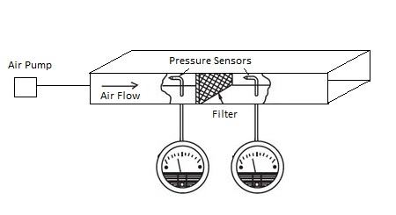

*Figure 4: Modular Filter Pressure Drop Tester*

*Table 4: Advantages and Disadvantages of Alternative Design 1*

|  |  |  |
| --- | --- | --- |
| Objective | Advantages | Disadvantages |
| Adjustable for various filters | Can fit all types of air filters, with respective adapters | Requires removal from the plane; removed filters cannot be reinstalled |
| Portability | Can be disassembled for transportation; Components can be moved by a single person without specialized equipment | Components require multiple back-and-forth trips |
| Ease of use | Disassembly allows for easy maintenance & cleaning, operation only requires reading dials and entering numerical values | -- |
| Low Cost | All the required materials are available online and easily to be purchased. The overall cost of the design is with budget | -- |

# 

# 2.2 Design 2 - Integrated Filter Monitor

In this design, an integrated air pressure monitor is installed in the air filter system. The design continuously monitors the air pressure decrease in a filter during its operating lifespan, and will track the gradual approach to the failure threshold. Instead of replacing the filters on a regular basis, the operators will know exactly when the airflow is too weak to replace the filters.

Filter Minder Inc. provides air pressure gauges that can be installed at the downstream of the air filter. Filter Minder Inc. provides mounted type air pressure gauge for air pressure application. The position indicator progressively fills the window as filter restriction increases, locking at the highest restriction. The filter should be changed when the position indicator reaches the red zone. The design allows the operators to know the air filter status during their maintenance schedule.

The operating condition of the air pressure gauge is between -40 to +121°C. This fits for Bombardier’s Aircrafts, since the temperature of the aircraft assumed as ISA+15°C according to Bombardier’s website on aircraft performance. [10]

Figure 5 below shows the example of the cabin filter system modified with air pressure gauge, the air filter monitor will be installed at the outer shell of the cabin air filter. The inlet pressure is 14.7psi. The monitor will constantly provide the reading of the outlet pressure.

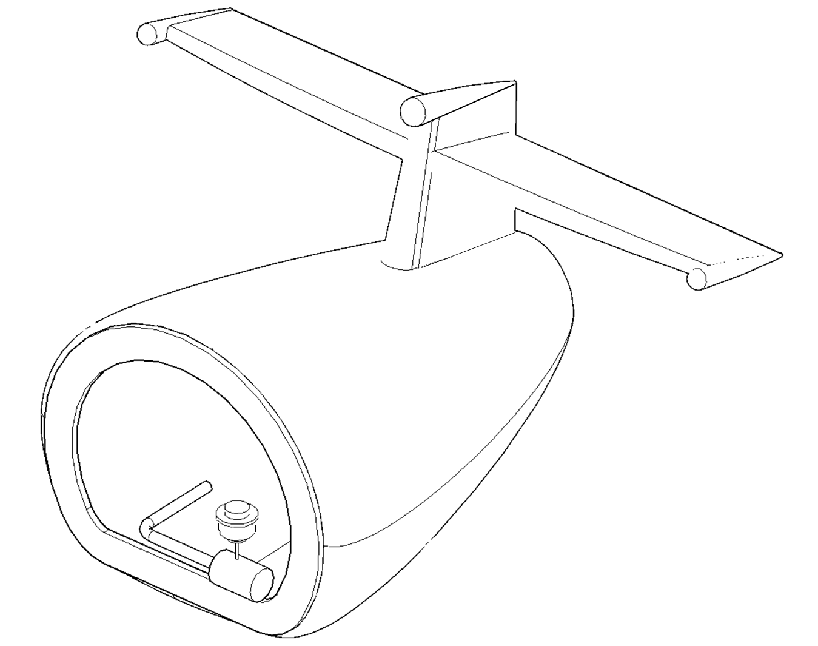

*Figure 5: Cabin Air Filter*

**2,2,1 Instrument Required**

|  |  |
| --- | --- |
| Industrial built-in pressure gauge | Specifications |
|  | Pressure Indicator  Locking Type (Non-Locking Available)  Operating Temperature:-40 to +121°C  Accuracy: ±10% at red zone  Material: Polycarbonate housing  Standard Calibration: 8-40" water vacuum (2-10 kPa) at the red zone |

*Figure 6: Integrated Filter Monitor* [35]

**2.2.2 Restriction**

Instead of taking the filter out to perform the test on its remaining life, this design will monitors the differential pressure of before and after the filters at any time. However, the restriction of the design is about its initial cost and installation. The air gauges needed to be installed on all aircrafts which will result in increased costs.

*Table 5: Advantages and Disadvantages of Alternative Design 2*

|  |  |  |
| --- | --- | --- |
| Objective | Advantage | Disadvantage |
| Adjustable for various filters | -- | Due to the size of the monitor, this design can only be used for the cabin air filter |
| Portability | The air pressure indicators are mounted onto the air filter system. No portable device is needed | -- |
| Ease of use | The mounted air filter monitors show readings of differential pressure at any time, which allows the operators get the status of the air filters easily | The air filter monitors need to be installed on all aircrafts that are in use, which result in extra amount of work and capital cost. |
| Low cost | No capital expenses, only a small increase to filter costs | Requires the replacement of current filters, may require costly modifications to the aircraft |

# 2.3 Design 3 - DOP Test - Breakthrough Curve

Filters start to let contaminant through once their sorbents become saturated, which is called breakthrough. This design is to determine the lifespan of the filters based on the sorbents (i.e. particulate matter) concentration difference across the filters. A breakthrough curve for each type of air filters will be generated beforehand based on DOP test (a method to test the integrity of HEPA filters using dispersed oil particulate [13]). To obtain the breakthrough curve, a new filter (provided by the Clients) will be tested under its normal operating conditions and the concentration difference across the filter will be continuously monitored till it passes the Failure Criteria (refer to section 2.3.3).

After three breakthrough curves have been plotted, the DOP test will be conducted again on the used filters (provided by the Clients). A typical breakthrough curve is shown in Figure 7. The C/C0 value will be calculated and given by the Aerosol Spectrophotometer. The corresponding time value of the testing result on the breakthrough graph tells the remaining lifetime of the filter.

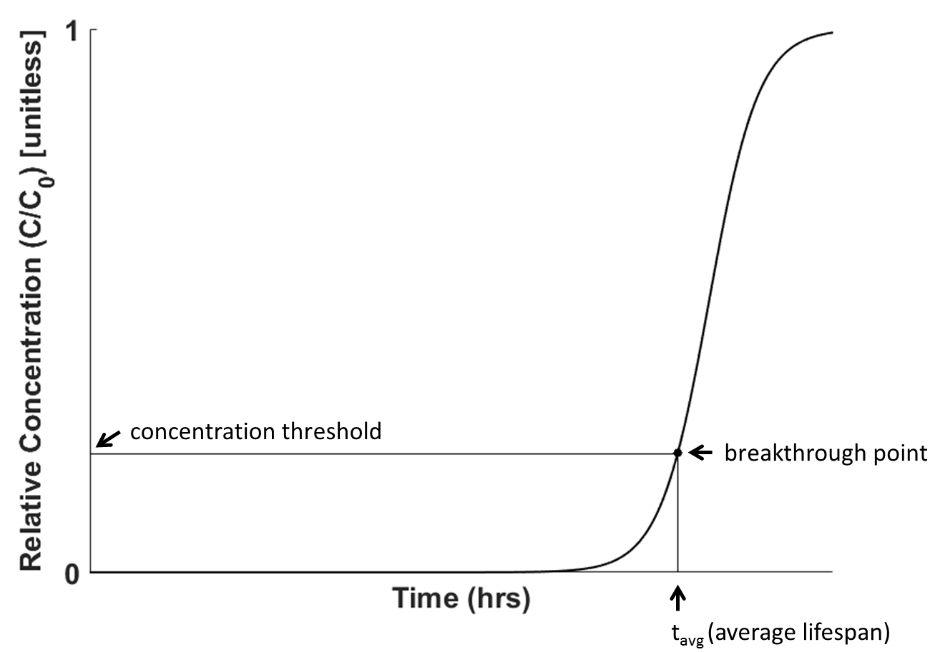

*Figure 7: A Typical Breakthrough Curve for air filters*

Notes: C is the downstream concentration

C0 is the upstream concentration

2.3.1 Instrument required

* DOP Aerosol Generator[20]
* Aerosol Spectrophotometer (Particle Counter)[21]
* Portable Air Compressor[22]
* Manometer

2.3.2 DOP Test Procedures

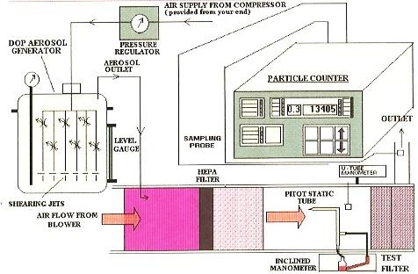

*Figure 8: DOP Test Rig [23]*

The test aerosol generated by the DOP generator is introduced into the system and the concentration(C0) is measured without the HEPA filter. The aerosol concentration set for the DOP generator is used to calibrate the particle counter. Then a filter is test under its normal operating conditions through adjusting the compressor (pressure and flowrate) and the DOP generator (temperature and concentration). The sampling probe takes in a small portion of air flow and analyzes the particle concentration in the filtered air. The photometer can be adjusted to count particles with different sizes to meet all three types of filters’ test requirements.

2.3.3 Filter Failure Criteria

All three types of air filters are from Q Series - Q400 aircrafts. The Q400 is designed for a shorter distance flights with up to 76 seats[11].

Cabin air filters is used to remove dust, allergens and microbes to provide safe and healthy environment. Donaldson as one of the Q400 air filter suppliers indicates that HEPA Filter (High Efficiency Particulate Air Filter) is widely used as the cabin air filter to capture coarse and fine particles[12]. According to the regulation, 99.97% minimum removal efficiency by DOP test (with a mean particle size of 0.3 micrometers)[13]. Therefore, the Cabin Air Filter will be considered as failed when more than 0.03 % of 0.3 micrometers particles detected by sampling probe.

Electronic equipment filters such as the Front Fuselage LCD Cooling Filter is used to protect sensitive equipment from dust and other contaminants. Donaldson, supplier of LCD cooling system filters, recommends an 800 hour maintenance interval[15]. A standard filter has minimum removal efficiency of 99.97% on 0.1 micrometers particles[15][16]. Hence, the threshold value of this type of filter is 0.03% with 0.1 micrometers particles injection across the filter.

There are three outflow valves, primarily controlled the outflow of air. The Pressurization Control Aft Safety Valve Filter[14] is used to remove particles (with size of 0.1 microns) in the air flow and ensure that the quality of exhaust air meet aircraft exhausting air regulation. 99.97% minimum removal efficiency should be meet. Therefore, the pressurization control aft safety valve filter is considered as failed when more than 0.03% of 0.1 microns detected[24].

2.3.4 Advantages & Disadvantages of the design

*Table 6: Advantages and Disadvantages*

|  |  |  |
| --- | --- | --- |
| Objective | Advantages | Disadvantages |
| Adjustable for various filters | - Fits all types of filters  - Aerosol Spectrophotometer has its inherent sampling probe to measure the downstream concentration | - Testing/assessment takes longer time, since calibration is needed before each run  - Filters needed to be removed from aircraft for the testing |
| Portability | - DOP test can be carried on site  - Components can be shipped to site | - |
| Ease of use | - Aerosol Spectrophotometer has its inherent minor which will show the downstream concentration and particles removal efficiency | - |
| Low cost | - Both Aerosol Generator and Aerosol Spectrophotometer can be leased from vendors | - High capital cost  - High maintenance cost |
| Easy to compare testing results with regulations | - The measurement gives the removal efficiency, which can be directly used to compare with regulation (refer to section 2.3.3) | -  - |

# 3.0 Proposed Design

The proposed pressure drop monitor was selected by using a pairwise comparison and weighted decision matrix system, as specified in Appendix A Figures A.1-A.4. The pairwise comparisons and weighted decision matrices were used to determine each design’s ability to meet the design project objectives outlined in Section 1.5. The design’s modular components prove the high portability of the design, while the adapter system allows for multiple filter types to be quickly tested, leading to a much-improved ease of use.

Implementing the pressure drop monitor design requires recreating a testing environment identical to the parameters specified in Section 1.7.5. The air pump system is intended to recreate the filtration systems as found on the aircraft of installation. Adapters specific for each filter shall be used to mount the respective filters to the design (see drafts for adapters for Aft Safety Valve filters and LCD filters in Figure 9.a-9.c below . The filters are easily placed inside the adapters and are secured with bolts.

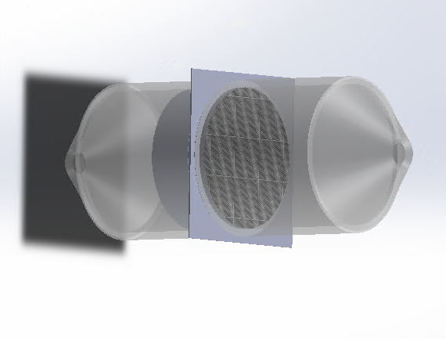

*Figure 9.a: adapters for Aft Safety Valve filter*

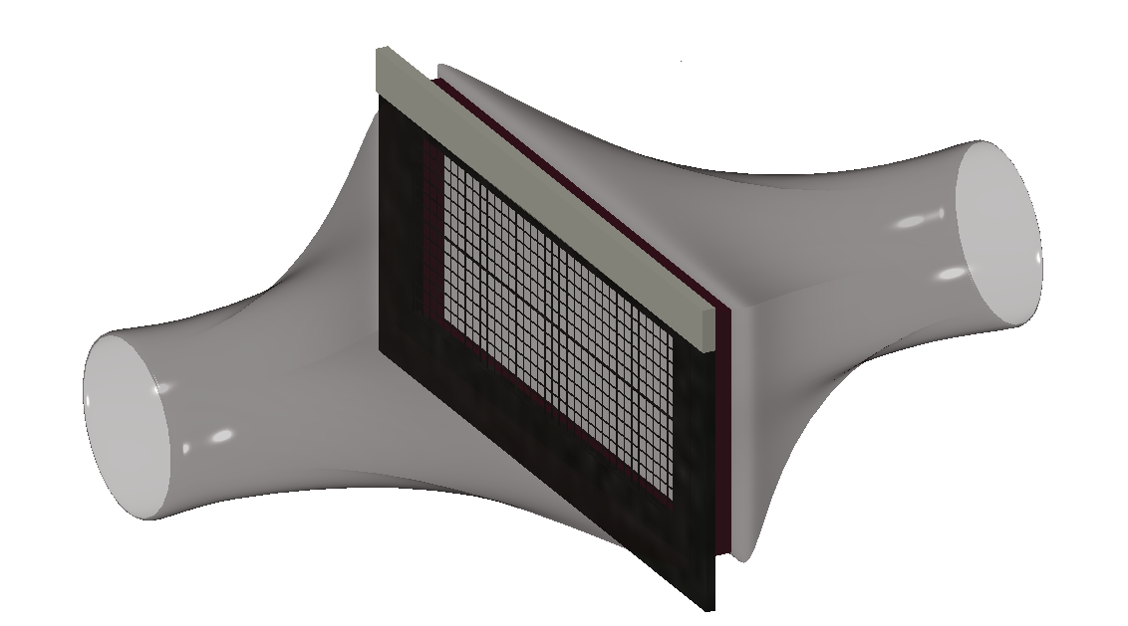

*Figure 9.b: adapters for LCD filters*

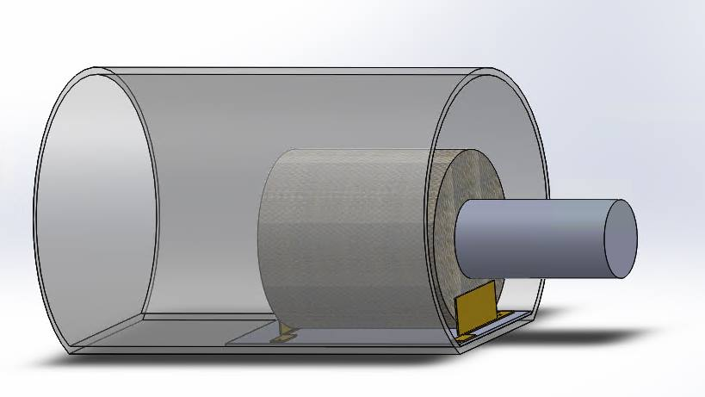

*Figure 9.c: adapters for Cabin Air Recirculation Filter*

For Cabin Air Recirculation Filter, since outlet air flows in axial direction, a chamber is designed (with a) to contain the filter and the pressure drop is then the difference between the pressure inside the chamber and the pressure upstream the filter.

Testing equipment to monitor the pressure and volumetric flow rates will be installed in the design, before and after the filter. A piping and instrumentation diagram for the design is shown in Figure 10 below.

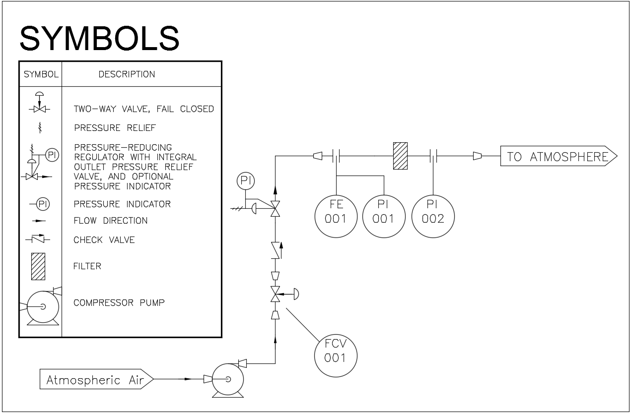

*Figure 10. Piping and instrumentation diagram, proposed design.*

As shown in the P&ID, the filters to be tested will be installed in the design. All three types of filters will be tested using different adapters custom-made for this design. A compressor pump is used to push the whole system. A flow control valve and a pressure-reducing valve are used to control the volumetric flowrate and the pressure upstream of the filter, according to the testing environment specified in Section 1.7.5. The pressure reducing valve is used to deal with the risk that air flow downstream pressurized by the compressor. After the air flow rate is stabilized and the pressure become steady(, which can be read from the flow element and pressure indicator), the readings in the two pressure indicator upstream and downstream the filter show the pressure drop interested.

# 3.1 Operational Principles

The operation of the pressure drop system is based on the principles of volumetric flow rate and relative pressure changes in a fluid system. A filter system’s internal geometry will cause internal pressure and volumetric flow changes, due to kinetic energy changes inversely proportional to potential energy changes. This is the functional theory behind Bernoulli’s principle, which is the primary factor governing the operation of this design for measuring the pressure drop.

The design assumes that the air is a compressible fluid moving at subsonic speeds, given the testing parameters outlined in Section 1.7.5 and the dimensions outlined in Section 1.7.6.

# 3.2 Preliminary Implementation Requirements

The Air Compressor (or the Blower) should provide a constant airflow across the filter. According to the Table 2 Input Parameters for Testing under Section 1.7.5, the minimum required airflow crossing the filter for testing process is 0.102 lb/min and the maximum required airflow is 57lb/min. Therefore, the capacity for this Air Compressor should be fit the following range: 0.1 lb to 114 lb of air provided per min.

Since the whole testing process is conducted at the ATM environment, the regular PVC tubes with standard size will be used to transfer the air from Blower to the adapter in where a tested filter will be placed. A tube Adapter is used to fit the tested filter. Since there are three types of filters with different dimensions (refer to table 3 under section 1.7.6) will be assessed, three adapters will be designed by the team.

Two pressure gauges will be installed before and after the filter to minor the pressure changes. Two flow meters in the system (one is installed right after the Blower, the other one is placed before the tested filter) to adjust and maintain the required flow rate (refer to section 1.7.5).

The air compressor, connecting tubes and all other instruments can be purchased from local store by the Client. The user must assemble the Modular Filter Pressure Drop Tester as per the design manual.

# 3.3 Preliminary Economics

The required components and materials are shown in the table below:

*Table 7: Required Parts and Estimated Costs*

|  |  |  |  |  |  |
| --- | --- | --- | --- | --- | --- |
| Part Number | Item Description | Quantity | Picture | Operating Condition | Estimate Cost |
| Part 1 | Single Stage Blower [25] | 1 | https://images1.mcmaster.com/mvA/contents/gfx/large/9960k62p1-d02b-digitall.png?ver=1423138918 | Maximum airflow rate:  92 CFM | $785.92/each |
| Part 2 | Stainless Steel[26] | 5 |  | 2’’ Thick, 6” *12* Yield strength: 30,000psi | $270/each |
| Air flowmeter[27] | 1 |  | Pipe size: 3  Range: 11.25-75lb/min | $936.86/each |
| Air flowmeter[28] | 1 |  | Pipe size: ¼  Range: 0.23-1.5lb/min | 637.98/each |
| Pressure gauge[29] | 2 |  | Connection size ¼  Range: 0-15 psi | $11.55/each |
| Part 3 | Safety Relief valve[30] | 1 |  | Connection size: ¼  Range: 25-200 psi | $5.88/each |
| Other | Seal materials/ Connection units | various |  |  | $100 |
| Total |  |  |  |  | $3,839.93 |

The maximum air flow rate is 57lb/min. The belt drive mobile fan can provide up to 420 lb/min of air passing through the filter. Two air flow meters are needed, one is for the cabin air filter which has air flow rate of 57lb/min, the other one is for the safety valve filter and LCD display filter, which has the flow rate of 0.102 and 2.2lb/min respectively. Pressure gauge has the range of 0 to15 psi, which is enough to measure the pressure of air at the atmosphere. Safety valve is to ensure the pressure in the chamber doesn’t go beyond the safety range. Additional seal material and connection units will be considered in the detailed design procedure.

# 3.4 Preliminary life cycle & environmental impact

Considering a large amount of air filters are installed every year, recycling or disposing them would be a problem [30].

There are three main components for a typical air filter: filter media, cardboard and metal. Each of those elements have its own recycling methods. However, it is not easy to separate those elements in a cost-effective manner[31]. Disposing the used air filters in the landfill will have a negative impact as it leads to greenhouse gas emission[31].

According to the Q400 Maintenance Packages, a typical Front Fuselage LCD Cooling Filter has a 1000 FH lifetime with a view to evolve to 1600 FH or higher and the current lifetime for a Pressurization Control Aft Safety Valve Filters is less than 4000 FH (but with a view to be evolved to 4800 FH or higher)[1][2]. As for the Cabin Air Distribution Recirculation Filter, a typical filter is discarded at the 5000 FH and the Client wanted to assess if it can last 5600 FH or higher[3].

By assessing the filters remaining lifetime and extending the current filter’s operating hours, the frequency of air filters replacement can be reduced, which helps lower the negative environmental impact.

With the proper maintenance program implemented, this Modular Filter Pressure Drop Tester could last about 15 years.

# 3.5 Preliminary human factors & Operational Method

Since this is a simple testing process, one operator is sufficient. Therefore, the adapter should be light enough to be lifted, moved or held by a single operator. The total weight of a single adapter should be less than 25 kg based on the ISO Standard 11228 Part 1[33] to meet the objective, portable. Handles are available on the adapter as part of inherent design. The operator can easily compare the pressure drop in inches of water (WC) and filter failure criteria (refer to section 1.7.5), using both pressure gauges installed in the system.

The air compressor and connecting tubes should be inspected at regular time intervals to prevent any gas leakage[32]. Instruments such as pressure gauges and flow meter should have visual inspection prior to each testing, and then after each run, the adapter should be cleaned and examined thoroughly to ensure the accuracy of testing results. The operator/user shall assemble and connect the parts as per the design manual.

# 3.6 Preliminary Test Plans

This section focuses on the testing of the objectives in Section 1.5 to demonstrate that the recommended design is successful and best meet these essential objectives. The objectives are to reduce the operating time and devices weight.

The phase of the project following the design proposal involves the initial development of a physical design prototype. The client, Bombardier, will provide a series of filters, as outlined in Section 1.7.4. The operating procedure is as discussed in Section 3.1. The time for stabilizing the flow as well as the time takes to change the filters (which need to partly disassemble and device and reassemble it) will be measured and compared with that of the apparatus the client is currently using. The weight of the disassembled components will also be measured.

# 3.7 Outstanding Decisions

This section focuses on the changes may be made as we move on to the details of the design. The modification will probably be made for safety and convenience reasons.

* The control valve used to adjust the volumetric flow rate in the system is not the typical arrangement generally used as shown in the figure below. The drain valves, block valves and the bypass designed for safety is removed for this design because the testing environment is under standard air pressure and room temperature, and the fluid in the system is atmospheric air. As we start to test our design, more fluid components may be added for better control.

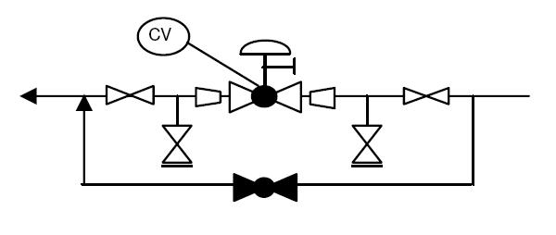

*Figure 11: Generally used control valve arrangement [34]*

* The arrangement of the pressure reducing valve may also be changed if the stabilization of the flow takes too long.
* The shape of the adapters designed for each filters will probably be changed in order to achieve a smaller pressure gradient near the filter (, so that the pressure measured will be more accurate and reliable).

# 4.0 Updated Project Management Plan

This section will display detailed tasks in our project that correspond to different time period and explain our strategies to make the project both cost and time efficient. Detailed tasks and timeline of the project are displayed in the Gantt Chart (Appendix C; Figure C.1) In order to summarize the entire project, milestones are displayed in the aforementioned Gantt Chart which includes all important activities for all three periods.

# 

# 5.0 Conclusion

In order to achieve client’s expectation, the design has the objective of being easily adjustable and operational, portable and low cost. The design should be able to fit for all three types of filters and provide accurate and reliable data in order to evaluate the remaining life span of the air filters. Different designs were proposed and ranked according to the objectives, and the Modular Filter Pressure Drop Tester was selected as the final design. The assembly and disassembly of this design is easy and it can accommodate all three types of filters. In next stage, a prototype of this design will be built to test the effectiveness of the design.

# 

# 

# 6.0 References

[1] Maintenance program, Bombardier Commercial Aircraft, May 2016, “Q400 Maintenance Program Evolution Sampling Requirements for the Pressurization Control Aft Safety Valve Filter”.

[2] Maintenance program, Bombardier Commercial Aircraft, May 2016, “Q400 Maintenance Program Evolution Sampling Requirements for the Front Fuselage LCD Cooling Filter”.

[3] Maintenance program, Bombardier Commercial Aircraft, May 2016, “Q400 Maintenance Program Evolution Sampling Requirements for the Cabin Air Distribution Recirculation Filter”.

[4] Worksafe NB, Aug. 2011 “Ergonomics Guidelines for Manual Handling”, Aug. 2011, [Online], Available: <http://www.worksafenb.ca/docs/MANUALEdist.pdf> Accessed: [19-Oct-2016]

[5] Maintenance program, Bombardier Commercial Aircraft, May 2016, “Recirculation System Filter”.

[6] Maintenance program, Bombardier Commercial Aircraft, May 2016, “Filter Front Fuse LCD Cooling”.

[7] National Centres for Environmental Information, Dec. 2015 “Global Analysis - Annual 2015”, [Online], Available: <https://www.ncdc.noaa.gov/sotc/global/201513> Accessed: [19-Oct-2016]

[8] Engineering Tool Box, “Relative Humidities in Production and Process Environments”, [Online], Available: <http://www.engineeringtoolbox.com/relative-humidity-production-process-d_511.html> Accessed: [19-Oct-2016]

[9]The Boeing Company, ”The Role of Computer Simulation in Reducing Airplane Turn Time”, [Online], Available: <http://www.boeing.com/commercial/aeromagazine/aero_01/textonly/t01txt.html> Accessed: [19-Oct-2016]

[10]"Challenger 650", Bombardier Business Aircraft, 2016. [Online]. Available: <http://businessaircraft.bombardier.com/en/aircraft/challenger-650> . [Accessed: 24- Nov- 2016]

[11] Bombardier Q400, Alaska, [Online], Available: <https://www.alaskaair.com/content/travel-info/our-aircraft/q400.aspx> Accessed: [Nov.17,2016]

[12] Commerical Aircraft, Donaldson Filtration Solutions, [Online], Available: <http://www.asia.donaldson.com/en/aircraft/applications/commercial.html> Accessed:[Nov.17,2016]

[13] Cabin Air, Pall Corporation, [Online], Available: <http://www.pall.com/main/aerospace-defense-marine/literature-library-details.page?id=46181#46197> Accessed: [Nov.17,2016]

[14] Air Conditioning & Pressurization(ATA21) Manual - Q400, Bombardier, [Online], Available: <http://www.smartcockpit.com/docs/Q400-Air_Cond_and_Press.pdf> Accessed: [Nov.17,2016]

[15] Donaldson P/N: P510547 and P510778 Avionics and LCD Cooling System Filters Bombardier P/N: 8SC0268-1 and 8SC0268-3, [Online], Available: <http://india.donaldson.com/en/aircraft/support/datalibrary/066234.pdf> Accessed: [Nov.17,2016]

[16] Protective Vents, Donaldson Filtration Solutions, [Online], Available: <https://www.donaldson.com/en/venting/all-products/protective-vents.html> Accessed: [Nov.17,2016]

[17] Cabin Environmental Control System, [Online], Available: <https://www.faa.gov/regulations_policies/handbooks_manuals/aircraft/amt_airframe_handbook/media/ama_Ch16.pdf> Accessed: [Nov.17,2016]

[18] DOP Testing Procedure, EACO, 2013, [Online], Available: <http://www.eacoontario.com/pdf/2013/Revised%20August%2027%202013%20DOP%20PAO%20HEPA%20IntegrityTesting%20Procedure.pdf> Accessed: [Nov.17,2016]

[19] HEPA Filters Still the Standard, Tradeline, 2007.6.19, [Online], Available: <https://www.tradelineinc.com/reports/2007-6/hepa-filters-still-standard> Accessed: [Nov.17,2016]

[20] DOP600C15 LASKIN NOZZLE AEROSOL Generator, Jamedoorla Technology Co., LTD, 2013.07.23, [Online], Available: <http://isureyu.en.ec21.com/DOP_600_C15_LASKIN_Nozzle--8326637_8332050.html> Accessed: [Nov.17,2016]

[21] ZR-6010 Aerosol Photometer Aerosol Spectrophotometer (particle counter), Yima Opto-electrical Technology Co., Ltd, [Online], Available: <https://yima.en.alibaba.com/product/60320442568-803040517/ZR_6010_aerosol_photometer_aerosol_spectrophotometer.html> Accessed: [Nov.17,2016]

[22]Portable Air Compressor, [Online], Available: <http://www.princessauto.com/en/detail/20-gallon-portable-air-compressor/A-p8474983e;jsessionid=aETIEbNTXUq1yJ51-KEd+e3K.pal-prod-com1> Accessed: [Nov.17,2016]

[23] IEICOS DOP Test Rig, [Online], Available: <http://www.ieicos.com/images/dop_test_rigs_large.jpg> Accessed: [Nov.17,2016]

[24] Real Time Measurements of Jet Aircraft Engine Exhaust, Kerry E. Kelly, 2015 [Online], Available: <http://patarnott.com/pdf/JetPA.pdf> Accessed: [Nov.17,2016]

[25]McMaster-Carr, “Air Fan, Blower”[Online], Available: <https://www.mcmaster.com/#standard-blower-fans/=156pemh> Accessed: [22-Nov-2016] [26]McMaster-Carr, “Stainless stell”[Online], Available: : <https://www.mcmaster.com/#standard-stainless-steel-sheets/=156ksml> Accessed: [22-Nov-2016]

[27]McMaster-Carr, “Flowmeters”[Online], Available: <https://www.mcmaster.com/#air-flow-rate-meters/=156l42t> Accessed: [22-Nov-2016]

[28]McMaster-Carr, “Pressure gauge”, blower”[Online], Available: <https://www.mcmaster.com/#pressure-gauges/=156l9b9> Accessed: [22-Nov-2016]

[29]McMaster-Carr, “Safety relief valve”, blower”[Online], Available: <https://www.mcmaster.com/#safety-relief-valves/=156la56> Accessed: [22-Nov-2016]

[30] Air Filter Life-Cycle Cost, Charles J. Seyffer, 2010/09/01 [Online], Available: <http://hpac.com/iaq-amp-ventilation/air-filter-life-cycle-cost> Accessed: [22-Nov-2016]

[31] Reitmeier is making zero waste a reality: HVAC Air Filters, Reitmeier, 2016/03/14 [Online], Available:

<http://www.reitmeiernw.com/reitmeier-is-making-zero-waste-a-reality-hvac-air-filters/> Accessed: [22-Nov-2016]

[32] Inspecting Air Compressors and Receivers, Business Database, 2012/11/23 [Online], Available: <http://businessdatabase.indicator.co.uk/business_advice_directory/articles/safe_use_of_machinery/inspecting_air_compressors_and_receivers/UKTAHSAR_EU110606/related> Accessed: [22-Nov-2016]

[33] Ergonomics Guidelines for manual handling, Worksafe NB, 2016 [Online], Available: <http://www.worksafenb.ca/docs/MANUALEdist.pdf> Accessed: [22-Nov-2016]

[34] Control Valvues [Online], Available: <http://www.enggcyclopedia.com/2011/04/control-valves-typical-pid-arrangement/> Accessed: [22-Nov-2016]

[35]F. Minder®, "Filter Minder® Graduated Position Air Pressure Monitoring Gauge", Filterminder.com, 2016. [Online]. Available: <http://filterminder.com/products/visual-mechanical-indicators-gauges/air-pressure-gauge.html> [Accessed: 25- Nov- 2016].

# Appendices

**Appendix A - Decision-Making Methodology**

This appendix details the decision-making method for selecting the final design from the options proposed in sections 2.1-2.4. The final design was selected by first ranking the project’s objectives by importance, using a pairwise comparison table (Appendix A, Figure 1). Next, using a weighted decision matrix, the objectives were given an importance weighting based on their rank from the pairwise comparison (Appendix A Figure 2). Each design was then evaluated for how well it could meet the objectives, with a 100% score indicating complete satisfaction (Appendix A, Figure 3). Finally, each design’s evaluation score was multiplied by the objective weight to determine the overall success of the design, quantifying the modular filter pressure drop monitor as the final design.

The pairwise comparison chart compares two objectives based on their relative importance to the project, versus each other. The more important objective is awarded a point (1), while the less important objective is awarded none (0). Once all objectives have been compared, the total score is tallied up, and then the ranking of importance for the objective can be determined.

*Figure A.1 - Pairwise Comparison Chart for Design Objectives*

|  |  |  |  |  |  |  |
| --- | --- | --- | --- | --- | --- | --- |
|  | Objectives | Easily adjustable for various filters | Portable | Easy to use | Low cost | Objective Score |
| 1 | Easily adjustable for various filters |  | 0 | 0 | 1 | 1 |
| 2 | Portable | 1 |  | 1 | 1 | 3 |
| 3 | Easy to use | 1 | 0 |  | 1 | 2 |
| 4 | Low cost | 0 | 0 | 0 |  | 0 |

For this table, we compare the four objectives with each other. Each objective is assigned with a number. For example, objective 1 is easily adjustable for various filters and objective 2 is being portable. The more important objective between each two objectives will be recorded on the table. The objective score indicate the numbers of each objective appears on the table. From the figure we can see that being portable is the most important objective among all the four objective.

The objective weight for each respective objective was determined by the rank determined in the pairwise comparison from Figure A.1. Then, based on the willingness to compromise between objectives, the weighting of each objective could be determined. Higher ranks will maintain higher weights, while lower weights indicate how willingly a client may sacrifice features of the design. See Figure A.2 below:

*Figure A.2: Objective Weight For Each Objective*

|  |  |  |
| --- | --- | --- |
| Objective | Rank | Weight |
| Portable | 1 | 45% |
| Easy to use | 2 | 30% |
| Easily adjustable for various filters | 3 | 20% |
| Low cost | 4 | 5% |
| Total | | 100% |

Each design is rated based on how well it meets a particular objective. Complete, uncompromising satisfaction is rated 100, with zero satisfaction garnering a rating of 0. These ratings are theoretical and based purely on the information provided for this project. See Figure A.3 below:

*Figure A.3: Design Objective Scoring Table*

|  |  |  |  |
| --- | --- | --- | --- |
|  | Design 2.1 | Design 2.2 | Design 2.3 |
| Portable | 80 | 100 | 80 |
| Easy to use | 95 | 70 | 50 |
| Easily adjustable | 70 | 30 | 70 |
| Low cost | 60 | 80 | 30 |

The final score, and thus proposed design, is determined by taking the design’s objective scoring from Figure A.3, and multiplying it by the respective objective weight from Figure A.2. This yields the weighted score, which can be used to determine a design’s theoretical feasibility with regards to the design objectives. The following figure demonstrates that Design 2.1, the modular filter pressure drop monitor, is the ideal candidate for the project:

*Figure A.4: Weighted Decision Matrix For Objective-Based Design Selection*

|  |  |  |  |
| --- | --- | --- | --- |
|  | Design 2.1 | Design 2.2 | Design 2.3 |
| Portable | 80*0.45 = 36 | 100*0.45 = 45 | 80*0.45 = 36 |
| Easy to use | 95*0.3 = 28.5 | 70*0.3 = 21 | 50*0.3 = 15 |
| Easily adjustable | 70*0.2 = 14 | 30*0.2 = 6 | 70*0.2 = 14 |
| Low cost | 60*0.05 = 3 | 80*0.05 = 4 | 30*0.05 = 1.5 |
| Total | **81.5** | **76** | **66.5** |

**Appendix B - Alternative Designs Generation**

Each design alternative is generated by analyzing the various methods to satisfy the functional requirements of the project, using problem decomposition methodology. Each of the functions, objectives, and constraints is separated into the smallest independent and relevant criteria. Beginning with functions, the flow rate must be analyzed to comply with the testing parameters outlined in Section 1.7.5, and the remaining life must be determined due to the operational lifespan differences per region. Secondly, the design alternatives are then eliminated if they do not satisfy the design constraints in Section 1.6. Finally, keeping the project objectives in mind, the decomposition method is used to determine valid solutions to the design problem.

According to the documents provided by the Client, pressure drop measurement is used as a failure criteria for filters, and thus the remaining lifespan. The first and second alternatives are based on the idea of monitoring the pressure drop across filters. In first design, pressure gauges are installed to measure the pressure decrease, while the second design continuously monitors the pressure once the device is installed on aircrafts.

The idea behind the third design came from the DOP (dioctyl phthalate) Test. DOP is a common aerosol whose particulate size can be adjusted to meet the supplier specifications for each filter, and the concentration of particles can be measured over a set time. Given the variance in concentration over the operational life of a filter, the remaining lifespan can be determined. Furthermore, given the potential spectrum of DOP particle sizes, the concentration change as a function of size can be determined, valuable for life-cycle analysis.

**Appendix C**

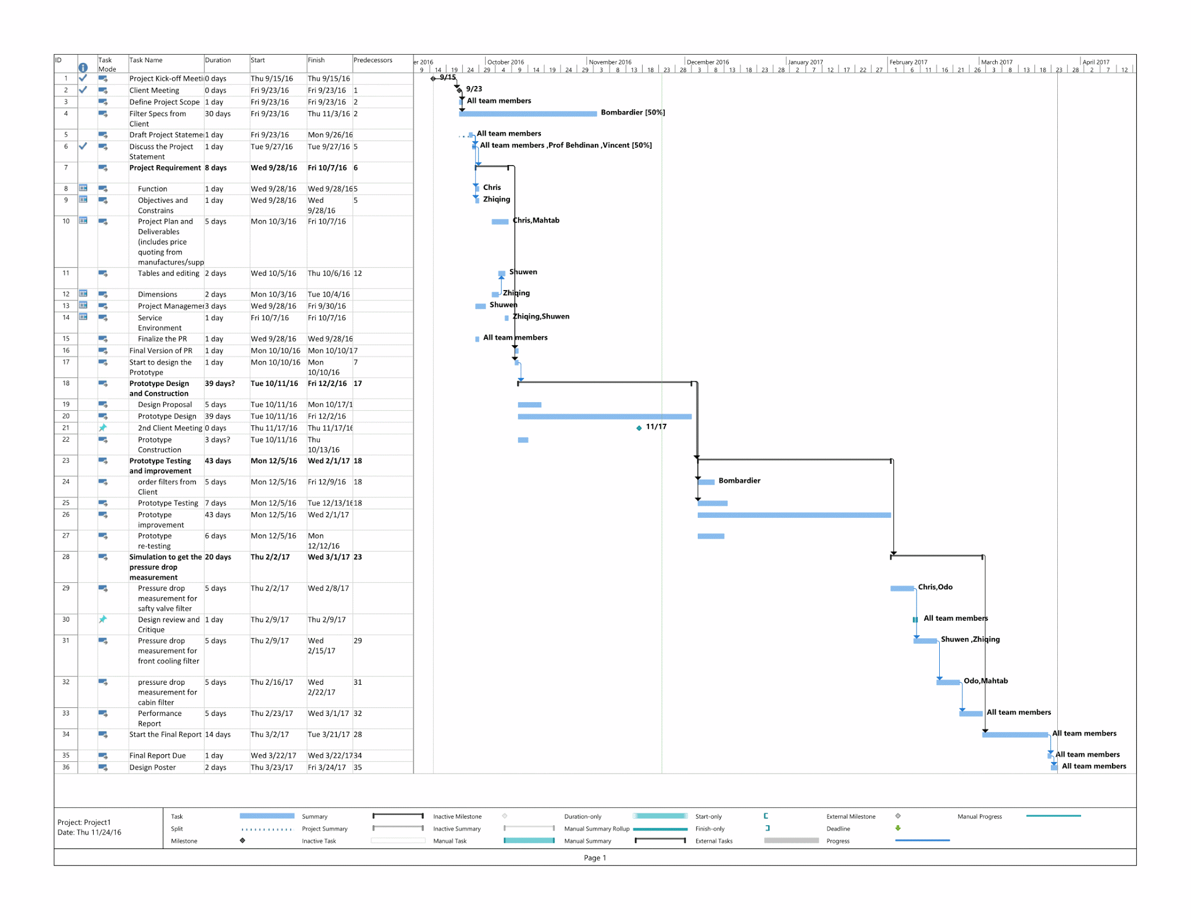*Figure C.1: Gantt Chart for Project Management*